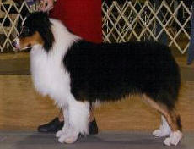  Cobbercrest Talk of the Town II  (Trent-Major Pointed) | CH Bluestems Man-O-Firethorne | CH Briarbrooks Black Arrogance | CH Briarbrooks Case In Point | CH Briarbrooks Valedictorian
 |  |  |  | Briarbrooks Oh My Oh
 | CH Bluestems Man-O-Firethorne | CH Briarbrooks Black Arrogance | CH Heatherhill Make Mine Mink | CH My Main Man of Heatherhill
 |  |  |  | CH Starswepts Made of Mink
 | CH Bluestems Man-O-Firethorne | CH Firethornes Finishin Touch | CH Briarbrooks Valedictorian | CH My Main Man of Heatherhill
 |  |  |  | CH Briarbrooks Silver Sequence
 | CH Bluestems Man-O-Firethorne | CH Firethornes Finishin Touch | Lakespringssohpisticatedtwist | CH Carolinas Oliver Twist CD
 |  |  |  | Sudden Reinbow of Copper Creek
 | CH Rushcreek Pillow Talk | CH McMatts EZ Going | CH McMatts EZ Victor | Castle Days of Thunder
 |  |  |  | CH McMatts All That Joy
 | CH Rushcreek Pillow Talk | CH McMatts EZ Going | CH Castles Image of McMatt | CH Caledonias Crowd
 |  |  |  | CH McMatts Sarahs Crystle Castle
 | CH Rushcreek Pillow Talk | CH Lil' Creeks As Requested | CH Kansaquest Before the Wind | Bayshores Run Four The Border
 |  |  |  | CH Kansaquests Shadow On The Sun
 | CH Rushcreek Pillow Talk | CH Lil' Creeks As Requested | CH Lil' Creeks Special Request | CH Heatherhill Sweet Talkin Dude CD
 |  |  |  | CH Lil' Creeks Picture Perfect
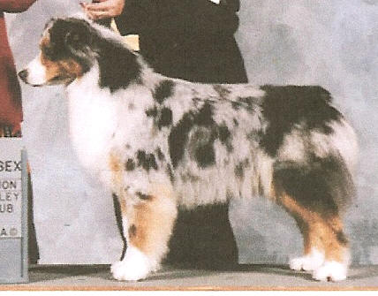  CH Fianns Silken Dalliance | CH Briarbrooks Valedictorian | CH My Main Man of Heatherhill | CH Agua Dulce Final Option | CH Winchesters Rollin Rapids
 |  |  |  | CH Country Hotline of Agua Dulce
 | CH Briarbrooks Valedictorian | CH My Main Man of Heatherhill | Moonspinner of Brigadoon | CH Brigadoons Moonraker
 |  |  |  | CH Windswept of Windermere CD
 | CH Briarbrooks Valedictorian | CH Briarbrooks Silver Sequience | CH Briarbrooks Coat of Arms | CH Fieldmasters Three Ring Circus
 |  |  |  | Fieldmasters Lodi
 | CH Briarbrooks Valedictorian | CH Briarbrooks Silver Sequience | CH Shadowmeres Close to Midnight | CH Briarbrooks Midnight Express
 |  |  |  | Briarbrooks Marque Ofpatchwork
 | CH Sienas Glorious M of Clankeep | CH Sienas Knockout CD | CH Sienas Sock it To Em | CH Briarbrooks Shake the Blues
 |  |  |  | CH Sienas Bahar of Shadowrock
 | CH Sienas Glorious M of Clankeep | CH Sienas Knockout CD | CH Tebos Angel in Blue | Cobbercrest To Ever Beat the Odds
 |  |  |  | Briarbrooks No Restrictions
 | CH Sienas Glorious M of Clankeep | CH Sienas Glory Be of Shadowmere | CH Briarbrooks Midnight Express | CH Fieldmasters Three Ring Circus
 |  |  |  | Glacier Crest Naughty Pine
 | CH Sienas Glorious M of Clankeep | CH Sienas Glory Be of Shadowmere | Briarbrooks Marque Ofpatchwork | CH Suns Mark of Windemere CD
 |  |  |  | Three Pine Carbine

